Name: Sapargali Temirlan
Group: SE-2403
Instructor: Aigul Adamova
PART 1
TASK 1
Deployment logs:
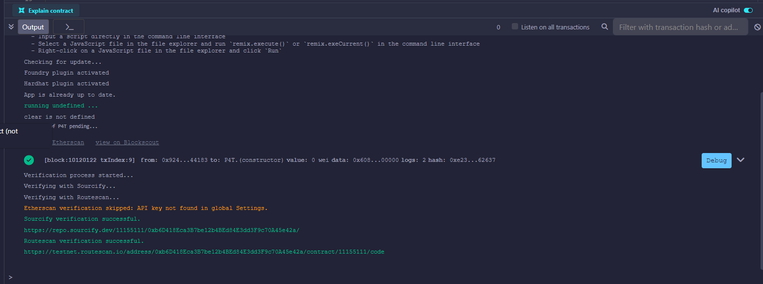
Transactions:
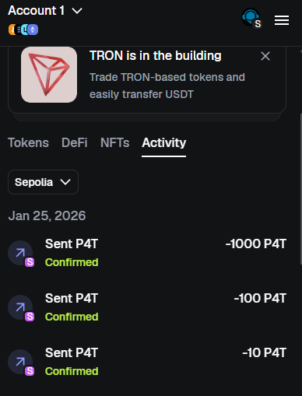
Contract address:
0xb6D418Eca3B7be12b4BEd84E3dd3F9c70A45e42a
ABI:
[
{
"inputs": [
{
"internalType": "string",
"name": "name_",
"type": "string"
},
{
"internalType": "string",
"name": "symbol_",
"type": "string"
},
{
"internalType": "uint256",
"name": "initialSupply",
"type": "uint256"
}
],
"stateMutability": "nonpayable",
"type": "constructor"
}, …
]

TASK 2
Deployment logs:
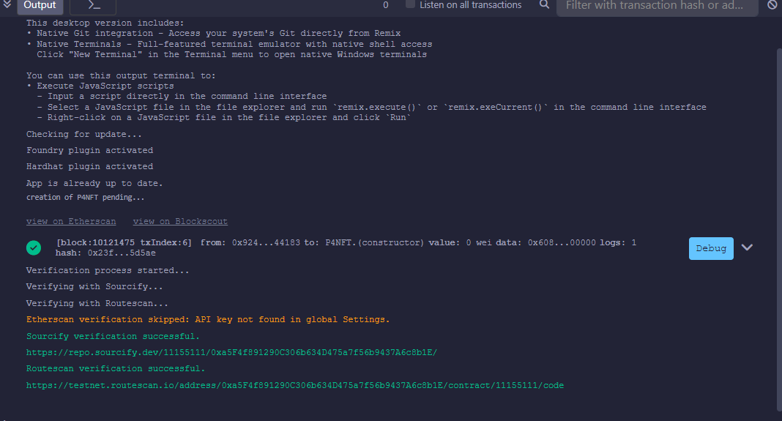
Contract address: 0xa5F4f891290C306b634D475a7f56b9437A6c8b1E
Deliverables:
